CLUTERING STUDENTS THROUGH DATA MINING AND GAMIFIED LEARNING

1.Abhishek Bhave 2.Mayank Mirani 3.Kedar Mane

4.Prof Deepali Nayak

1,2,3. Final year (B.E) student, Department of Information technology, Vidyalankar Institute of Technology (Affiliated to Mumbai University) Mumbai, India

4. Assistant Professor, Department of Information technology, Vidyalankar Institute of Technology (Affiliated to Mumbai University) Mumbai, India

*Abstract*— Gamified learning is an educational approach to motivate students to learn by using game design and game elements in learning environments and to maximize engagement through capturing the interest of learners and inspire them to continue learning.

Gaming is a popular pastime and 40% of Indian teenagers tend to play for more than 6 hours per week. Currently, less than 10 % of Indian corporates use gamification actively and fewer than 3 % education institutes make use of gamification. However it is a domain that is readily sought after and much scope is present in this sector. E-learning industry is growing rapidly and will continue to do so in the next 10-20 years. Educational data mining [EDM] is one of the solutions to improving learning and grasping power of students on a broader scale rather than being confined to an individual student’s level.

Analysis on learner’s behavior, prediction on future results, cognitive learning and level of fundamental knowledge acquired are some of the major analysis done on E-learning data. This project aims to create a game for students which they play and thus faculty get the appropriate data about student’s skill, weak and strong areas so as to personalize learning for every student and to improve learning experience.

Keywords—gamification;personlisation; education; evaluation; analysis; student; faculty; game engine; game;data mining; clustering

# Introduction

The gamification of learning is an educational approach to motivate students to learn by using video game design and game elements in learning environments. The goal is to maximize enjoyment and engagement through capturing the interest of learners and inspiring them to continue learning.

Gamification is starting to play an important role in education with the objective of providing engagement and improving the motivation of students.

We plan to cluster the students on the basis of the score they generate with help the game and analyze them based on their performance and provide suitable recommendations.

This paper is designed and contains a systematic approach of clustering with help of data mining and gamified learning.

# AIM ANd OBjectives

* The aim of our project is to improve learning and motivation of students through fun games / game-based environment and interactive sessions.
* Also we aim to create an innovative teaching - learning methodology with feed-back system for courses that can benefit educational system.
* The approach will also help for overall analysis of student potential on a concept by using data clustering algorithms and providing the students feedback on their knowledge of the subject.
* This approach will also streamline manual data generated in the educational sector and apply data mining algorithms to recognize patterns to provide recommendations to the student based on their performance.

# Problem Statement ANd the Scope

Data in educational sector is readily available but there has not been enough analysis done on that available data. There is a dearth of student teacher interaction and motivation for learning. Improving student teacher interaction and thereby introducing new teaching methodologies and ideas. Learning experience and personalized learning is the future of education. There has been a failure to integrate data mining analytics with gamification in learning. Many projects have failed to achieve common integration in gamification with data mining. Also all existing educational data mining applications and systems are rudimentary in nature and fail to achieve appropriate evaluation and gamification.[7] Improving learning experience and personalization in learning requires innovative solutions and gamification is one such solution. This project will mainly involve students who are to be taught and teachers in a supervisory role.

The scope of this project mainly revolves around:

1. Data Analysis

This project aims to do clustering of data that is generated from gamification. As a result of clustering, we hope to establish baseline clusters to evaluate performance of students on the game.

2. Evaluation

One of the goals of this project is to evaluate the standard or skills of a student with the use of gamification. Here the student is asked to complete a game depending on the course that is taught and on the basis of that clustering is done.

3. Recommendation

In this system, once the clustering of students is done according to the score of the game, recommendation will be given to the students as per their score.

# Proposed System

The proposed system will be a web based application which will have different modules for students to play as part of gamification. The application essentially has 3 main blocks or components.[3] They are student, faculty and lastly the game portion of the application. The game component of the application involves game architecture, game design as well as the game engines to be used. This will be the framework which will run the game as is essentially the most important part of the application.

The other blocks or components of the web based system are the student and the faculty. The student will be first required to register using credentials and then select the appropriate module he/she is studying. The student will then play and complete the game after which scores will be generated using weights and clustering of students will be done according to appropriate score. Once evaluation and clustering has been completed, the student will be given the appropriate resources to study and improve their skill.

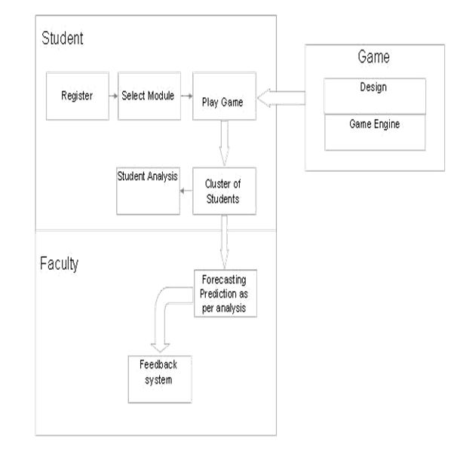

Figure 1

The block diagram contains the following information:-

1. Student: - The student block contains register, select module, play game, cluster the students, student analysis.

1a. Register: - Every student must register in order to play the game.

1b. Select Module: - Student must select the module based on which the game will be played.

1c. Play game: - This will redirect to the Game block where the game will be played and result will be stored.

1d. Cluster the Students: - The students with similar score will be clustered together.

1e. Student analysis: - Students will be analyzed based on their score and suitable recommendations will be given on the aspects of the module.

1. Faculty: - The faculty receives the clustered data from the students’ performance based on the way they play the game and the faculty also provides with feedback.

2a. Forecasting prediction as per analysis: -

Here the clustered data of students is provided to the faculty which can be easily analyzed.

2b. Feedback: - The Faculty then can provide with suitable feedback to an individual based on their performance and motivate them to excel in the module.

1. Game: - This contains the game design and the game engine which connects the students with the game.

3a. Game: - This is very important aspect when you are dealing with game. To deal with games means the game design should be spot on hence we plan to use interactive and entertaining games like puzzles, crosswords, pictorials, etc. to help students inculcate with the game and us to cluster them properly and provide suitable feedback

3b. Game Engine: - The game engine needs to very fast and responsive hence we are planning to use pixi.js and Babylon.js for game rendering and gamesalad.com as the prime user interface of the game application.

|  |  |
| --- | --- |
| Game Level | Type of Questions |
| Easy | Prerequisites of the module. |
| Medium | Based on introduction and early understanding of the module |
| Hard | Questions based on the whole module |

Iterative approach is to be followed during the course of the completion of the project. These iterations can be briefly explained as: -

Iteration 1 -Data Collection using Gamification

In this step, the score is generated by answering all the questions in the game and that data along with the ID of the student will be used as the input in the next iteration.

Iteration 2- Data preprocessing and Analysis

Here, data preprocessing will take place. Noisy data, inconsistent data will be standardized and clustering will take place using data mining tool.[6] Clusters of students with similar characteristics will be generated and displayed using Tableau tool.

Iteration 3 - Faculty Feedback system after clustering In this step, as soon as the scores are generated and clustering is done, there will be input taken from the faculty from the improving the learning or knowledge of the chapter for different variety of students.

# APPROACH

Computer-adaptive tests are designed to adjust their level of diﬃculty- based on the responses provided to match the knowledge and ability of a test taker. If a student gives wrong answer the computer follows up with an easier question; if student answers correctly, the next question will be more diﬃcult.[4] Considered to be on the leading edge of assessment technology, computer-adaptive tests represent an attempt to measure the abilities of individual students more precisely, while avoiding some of the issues often associated with the one-size-ﬁts-all nature of standardized tests.

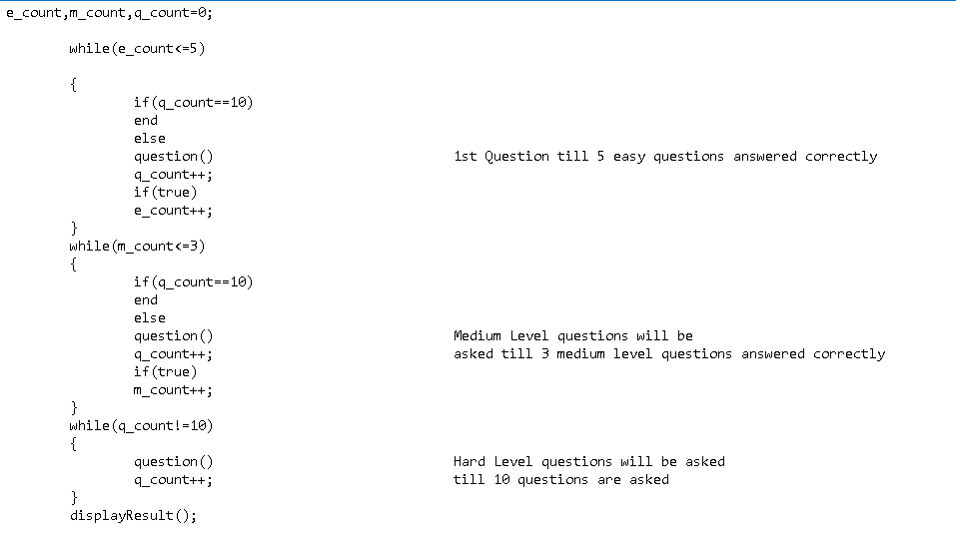

K-MEANS CLUSTERING ALGORITHM

1. Place K points into the space represented by the objects that are being clustered. These points represent initial group centroids.

2. Assign each object to the group that has the closest centroid.

3. When all objects have been assigned, recalculate the positions of the K centroids.

1. Repeat Steps 2 and 3 until the centroids no longer move. This produces a separation of the objects into groups from which the metric to be minimized can be calculated.

# IMPLEMENTATION

Visual Studio IDE was used for the implementation. We developed a web-based UI for the Personalized Education and Evaluation System. The front end System was implemented using HTML, Visual C# and Javascript.

MySQL database was used to store user registration details, login details, data generated by the users. The details of every student are stored in the MySQL database in order to facilitate the implementation of project.

The Following Image shows Student Registration form:-

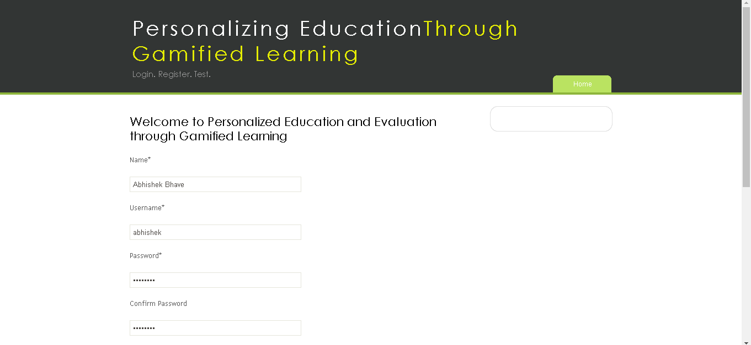

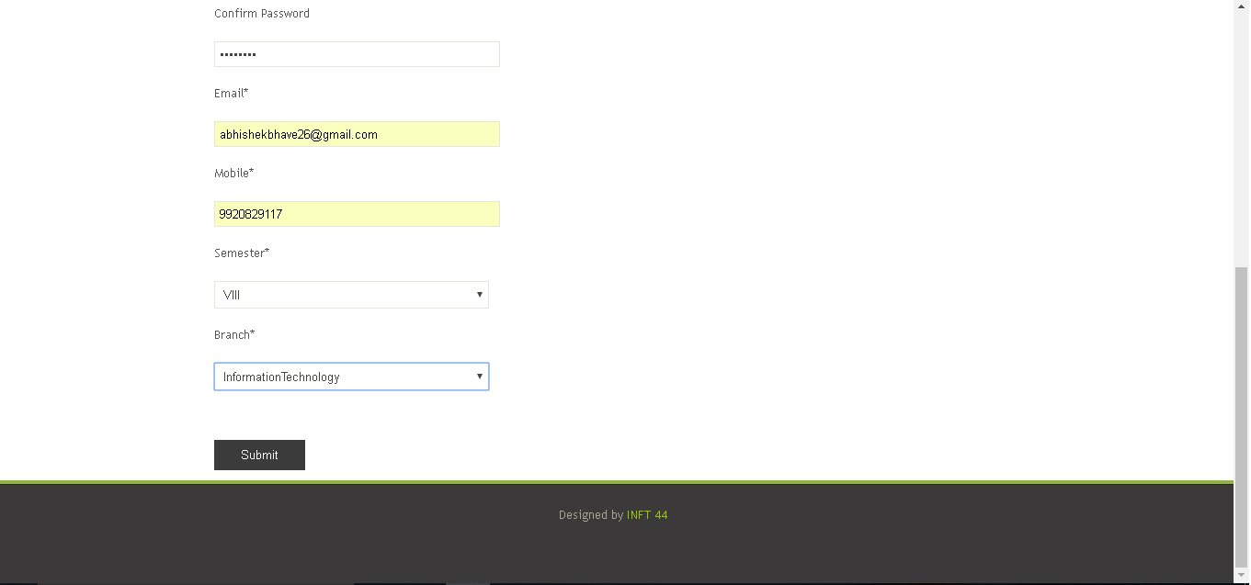

The Following Image shows Student Login:-

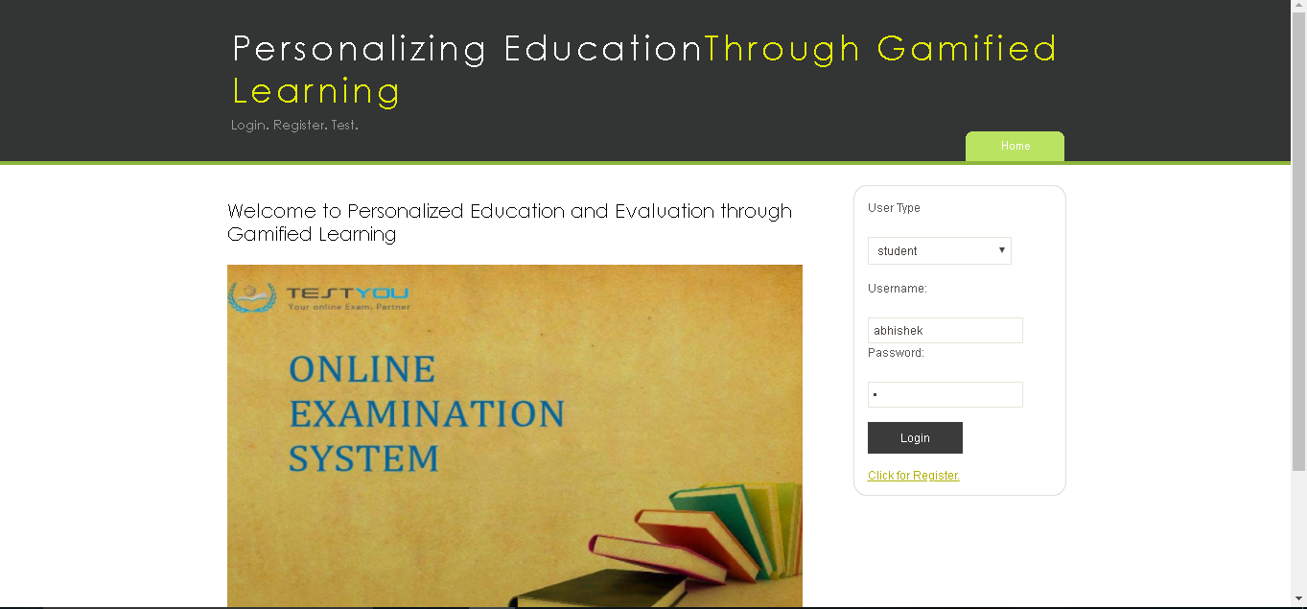

The Following Image shows Questions:-



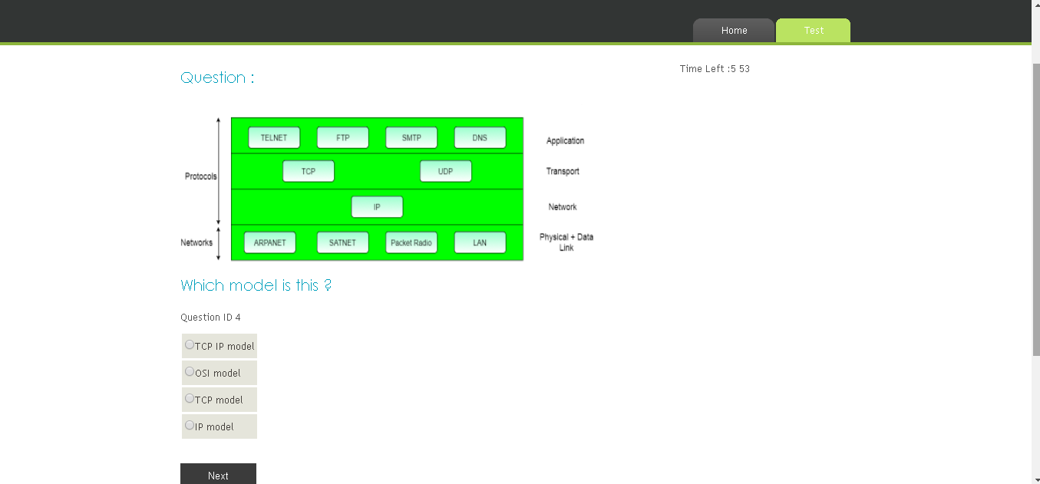



This Image shows result of student after taking the test:-



This Image shows staff result page:-

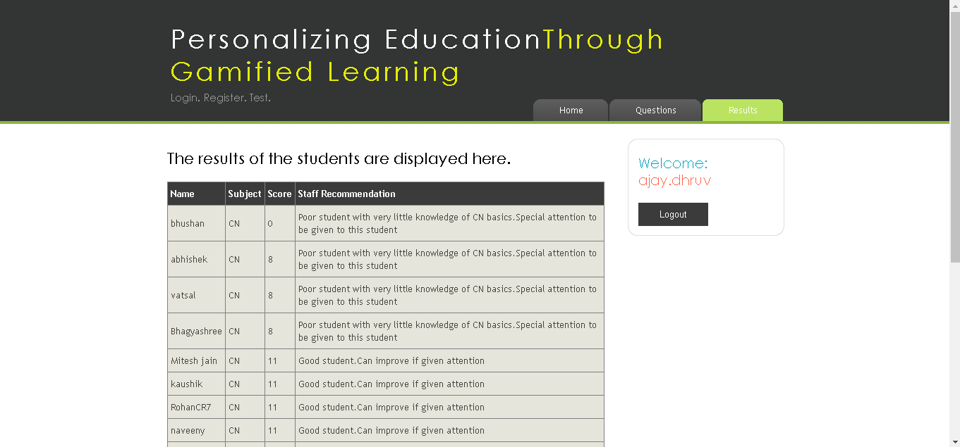

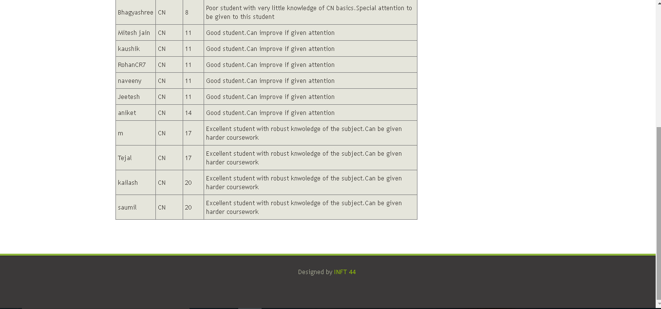

VII.TECHNOLOGY USAGE

1. Gamification Project is a Web Based application.2D game engines like pixi.js and babylon.js will be used for game rendering. These game engines are suitable for rendering games on web applications. Also, gamesalad.com will be used for making the user interface of the game as a web application.

2. Visual Studio 2013 and SQL server 2014 will be used for creating the interface and for databases respectively.

3. K-means Clustering algorithm is used as it has enhanced visualization features.

4. Data Preparatory software to be used for data preprocessing.

5. Amazon web services will be used to host our project as they offer hosting at miniscule costs and also offer wide variety of features like servers and database support.

##### References

[1] Bernik, A., Radoseviˇc,´ D., & Bubas,ˇ G. (2017). Introducing gamification into e-learning university courses. In 40th jubilee international convention-mipro 2017.

[2] Cechetti, N. P., Biduki, D., & De Marchi, A. C. B. (2017). Gamification strategies for mobile device applications: A systematic review. In Information systems and technologies (cisti), 2017 12th Iberian conference on (pp. 1–7).

[3] Fraser, G. (2017). Gamification of software testing. In Proceedings of the 12th international workshop on automation of software testing (pp. 2–7).

[4] Muntean, C. I. (2011). Raising engagement in e-learning through gamification. In Proc. 6th international conference on virtual learning icvl (pp. 323–329).

[5] Wen, M.-H. (2017). Applying gamification and social network techniques to promote health activities. In Applied system innovation (icasi), 2017 international conference on (pp. 531–534).

[6] Yue, W. S., & Ying, C. Y. (2017). The evaluation study of gamification approach in Malaysian history learning via mobile game application. In Advanced learning technologies (icalt), 2017 IEEE 17th international conference on (pp. 150–152).